

**RISK MANAGEMENT PLAN**

**This form consists of a Project Information page and Risk Register. You are required to complete both pages and submit for approval prior to commencing any project.**

**The form is linked to the** [**Risk Management Policy and Guide**](http://www.bee.qut.edu.au/study/current/health/documents/CP097V7RMPolicyApr2010.doc) **(CP097), which should be read prior to completing this form and contains guidance notes, examples of common hazards, predictable risks and suggested controls.**

**Use the hyperlinks in this document to access additional information, guidance notes and common project risk details.**

|  |
| --- |
| [Project Title](http://www.bee.qut.edu.au/study/current/health/documents/CP097V7RMPolicyApr2010.doc" \l "title) – Autonomous Helicopter Navigation System (AHNS) |

|  |  |  |  |  |  |  |  |  |  |  |  |  |  |  |  |  |  |  |  |  |  |  |  |  |
| --- | --- | --- | --- | --- | --- | --- | --- | --- | --- | --- | --- | --- | --- | --- | --- | --- | --- | --- | --- | --- | --- | --- | --- | --- |
| **Project Type** (tick appropriate box / boxes) | | | | | | | | | | | | | | | | | | | | | | | | |
| [**UG Project**](http://www.bee.qut.edu.au/study/current/health/documents/CP097V7RMPolicyApr2010.doc#ugproj)  **(Individual or Group)** | |  | [**PG Project**](http://www.bee.qut.edu.au/study/current/health/documents/CP097V7RMPolicyApr2010.doc#pgproj)  **(Individual or Group)** | | |  | [**Staff Research Project**](http://www.bee.qut.edu.au/study/current/health/documents/CP097V7RMPolicyApr2010.doc#stafresearch) | | | |  | | [**Site Visit**](http://www.bee.qut.edu.au/study/current/health/documents/CP097V7RMPolicyApr2010.doc#offcamp) | |  | | [**Asset / Equip Procurement**](http://www.bee.qut.edu.au/study/current/health/documents/CP097V7RMPolicyApr2010.doc#procurement) | | | | | | |  |
|  | |  |  | | |  |  | | | |  | |  | |  | | [**Corporate Level Project**](http://www.bee.qut.edu.au/study/current/health/documents/CP097V7RMPolicyApr2010.doc#corp) | | | | | | |  |
| [**UG Class Exercise**](http://www.bee.qut.edu.au/study/current/health/documents/CP097V7RMPolicyApr2010.doc#ugclass) | |  | **[PG Class Project](http://www.bee.qut.edu.au/study/current/health/documents/CP097V7RMPolicyApr2010.doc" \l "pgproj)**  **[or Tutorial](http://www.bee.qut.edu.au/study/current/health/documents/CP097V7RMPolicyApr2010.doc" \l "pgproj)** | | |  | [**Collaborative Project**](http://www.bee.qut.edu.au/study/current/health/documents/CP097V7RMPolicyApr2010.doc#colab) | | | |  | | [**Field Activity**](http://www.bee.qut.edu.au/study/current/health/documents/CP097V7RMPolicyApr2010.doc#offcamp) | |  | |  | | | | | | |  |
|  | |  |  | | |  |  | | | |  | |  | |  | | [**Commercial Project**](http://www.bee.qut.edu.au/study/current/health/documents/CP097V7RMPolicyApr2010.doc#commerc) | | | | | | |  |
| [**UG Tutorial**](http://www.bee.qut.edu.au/study/current/health/documents/CP097V7RMPolicyApr2010.doc#ugclass) | |  | [**PG Research Project**](http://www.bee.qut.edu.au/study/current/health/documents/CP097V7RMPolicyApr2010.doc#pgresearch) | | |  | [**Work Activity**](http://www.bee.qut.edu.au/study/current/health/documents/CP097V7RMPolicyApr2010.doc#work) | | | |  | | [**Social Networking**](http://www.bee.qut.edu.au/study/current/health/documents/CP097V7RMPolicyApr2010.doc#social) | |  | | **Domestic** | | | |  | **Overseas** | |  |
| **[Project Category](http://www.bee.qut.edu.au/study/current/health/documents/CP097V7RMPolicyApr2010.doc" \l "category)** (School / Portfolio / Discipline) | | | | | | | | | | | | | | | | | | | | | | | | |
| **Engineering Systems**  (Specify Discipline Below) | | |  | **Design**  (Specify Discipline Below) | | | |  | **Urban Development**  (Specify Discipline Below) | | | | | | |  | | | | **Research**  (Specify Discipline Below) | | |  | |
| Aerospace Avionics Engineering | | | |  | | | | |  | | | | | | | | | | |  | | | | |
| **Teaching & Learning** | | |  | **Faculty Operations** | | | |  | **External Relations** | | | | | | |  | | | | **Other (detail below)** | | |  | |
| **Other** | | | | | | | | | | | | | | | | | | | | | | | | |
| **[Project/Work Details](http://www.bee.qut.edu.au/study/current/health/documents/CP097V7RMPolicyApr2010.doc" \l "details)** (Provide details of the exact nature of work – If space insufficient, add a page)  Attach copies of SOP, sketch, design, permit, authority or other relevant documents | | | | | | | | | | | | | | | | | | | | | | | | |
| The aim of the AHNS project is to develop a hardware and software solution to automate a small size electric helicopter for indoor environments. Traditionally, the automation of a Micro Air Vehicle (MAV) such as a small size electric helicopter has relied on GPS as its primary tool for navigation. However due to the environmental restrictions on the project, other navigational means are required since GPS cannot be used indoors. The proposed navigational solution to achieve automation is a combinational approach consisting of inertial measurements and computer vision. Utilising these two concepts will allow the states of the platform to be estimated and ultimately controlled through the use of an onboard flight computer. | | | | | | | | | | | | | | | | | | | | | | | | |
| **[HELP](http://www.bee.qut.edu.au/study/current/health/documents/CP097V7RMPolicyApr2010.doc" \l "otherdetails)** | **Project Location: GP-S1114 (Design and Construction)**  **(site, room, etc) ARCAA Brisbane Airport Building (Testing)** | | | | | | | | | | | | | | **Proposed commencement date**  **22nd February 2010** | | | | | | | | | | |
| **Project Team Members names**  **Contact phone/mobile numbers**  **Student ID No. If applicable**  (Attach list if necessary) | | | | | **Names:** (Please Print) | | | | | | | **Student ID No.** | | | | | | **Contact Phone / Mobile N0.** | | | | | | |
|  | | | | | **Michael Hamilton** | | | | | | | **06219314** | | | | | | **0408120889 (mob)** | | | | | | |
|  | | | | | **Michael Kincel** | | | | | | | **06219322** | | | | | | **0423474895 (mob)** | | | | | | |
|  | | | | | **Tim Molloy** | | | | | | | **06332064** | | | | | | **0403410247 (mob)** | | | | | | |
|  | | | | | **Liam O’Sullivan** | | | | | | | **06308627** | | | | | | **0407641612 (mob)** | | | | | | |
|  | | | | |  | | | | | | |  | | | | | |  | | | | | | |
| **Project Supervisor/s**  **(Name & Phone number)** | | | | | **Name**  **DR Luis Mejias Alvarez** | | | | | | | | | **Phone No.**  **3138 1411** | | | | | | | | | | |
| **Valid to / Review by** (Insert DATE) | | | | | **Actual Review Date** | | | | | **Reviewed By** (Please Print) | | | | | | | | | **Signature** | | | | | |



**Use the hyperlinks in this document to access additional information, guidance notes and common project hazards, risk & controls contained in** [**CP097**](http://www.bee.qut.edu.au/study/current/health/documents/CP097V7RMPolicyApr2010.doc)**.**

**Risk Assessment and Risk Register**

[**(How to conduct a Risk Assessment)**](http://www.bee.qut.edu.au/study/current/health/documents/CP097V7RMPolicyApr2010.doc#conductRA)

|  |  |  |  |  |  |  |
| --- | --- | --- | --- | --- | --- | --- |
| **No** | **Hazard, Activity, Task, or Process**  [(Go to Hazard Categories)](http://www.bee.qut.edu.au/study/current/health/documents/CP097V7RMPolicyApr2010.doc#hazcat) | **Identified Risks** | **Risk Level**  **Initial** | **Proposed Control Measures**  **(All control measures must comply with legislative requirements and follow the** [**Control Hierarchy**](http://www.bee.qut.edu.au/study/current/health/documents/CP097V7RMPolicyApr2010.doc#hierarchy)**.** | **Residual**  **Risk Level**  **Final** | **Notes / Remarks**  1) Who is responsible to implement controls?  2) Latest implementation date?  3) Other relevant detail. |
|  |  |
| 1 | *Flight Testing Risks – (pp 22-23)* | *Refer to AHNS-2010-SY-PM-002* | High | *Refer to AHNS-2010-SY-PM-002* | Low | 1) Project Manager  2) 06/03/10  3) |
| 2 | *Personal Injury Risks – (pp 24-26)* | *Refer to AHNS-2010-SY-PM-002* | Moderate | *Refer to AHNS-2010-SY-PM-002* | Low | 1) Project Manager  2) 06/03/10  3) |
| 3 | *Property Damage Risks – (pp 10-14)* | *Refer to AHNS-2010-SY-PM-002* |  | *Refer to AHNS-2010-SY-PM-002* | Low | 1) Project Manager  2) 06/03/10  3) |
| 4 | *Schedule Risks – (pp 27-33)* | *Refer to AHNS-2010-SY-PM-002* | Extreme | *Refer to AHNS-2010-SY-PM-002* | Low | 1) Project Manager  2) 06/03/10  3) |
| 5 | *Technical Risks – (pp 34-42)* | *Refer to AHNS-2010-SY-PM-002* | High | *Refer to AHNS-2010-SY-PM-002* | Low | 1) Project Manager  2) 06/03/10  3) |
| 6 | *Budgetary Risks – (pp 43-45)* | *Refer to AHNS-2010-SY-PM-002* | High | *Refer to AHNS-2010-SY-PM-002* | Low | 1) Project Manager  2) 06/03/10  3) |

|  |  |  |  |  |  |  |  |  |  |  |
| --- | --- | --- | --- | --- | --- | --- | --- | --- | --- | --- |
| **Risk Assessment** [**Conducted By**](http://www.bee.qut.edu.au/study/current/health/documents/CP097V7RMPolicyApr2010.doc#conductRA)  **(Author)** | Name (Print)  Michael Hamilton | | | Appointment  Student Manager | | Student No (If Applicable)  06219314 | | Signature | | Date |
|  | |  |
| I certify that I have consulted with appropriate personnel and have considered professional advice and/or relevant information in conducting this assessment and have obtained necessary approvals, permits, licences as applicable to the project. | | | | | | | |  | |  |
| **APPROVAL *Note> Individuals approving this document accept responsibility for the appropriateness of controls and for the validity of the Risk Management Plan.*** | | | | | | | | | | |
| [**Approved By**](http://www.bee.qut.edu.au/study/current/health/documents/CP097V7RMPolicyApr2010.doc#approver) | | **Name**  (PRINT) |  | | **Appointment / Title** | | **Signature** | | **Date** | |

**Distribution:**

* **Original (Hard Copy) held by Author for duration of project and must be available to management, health and safety personnel, WH&S QLD Inspector or other authorised person on request.**
* **Electronic or Hard Copy held by Approver for the duration of the project.**
* **Electronic (preferred) or Hard Copy forwarded by Author to Faculty Health & Safety Section –** [**m.goddard@qut.edu.au**](mailto:m.goddard@qut.edu.au) **Room S1124 GP within 7 Days of approval.**

**Risk Calculator**

Return to Risk Register

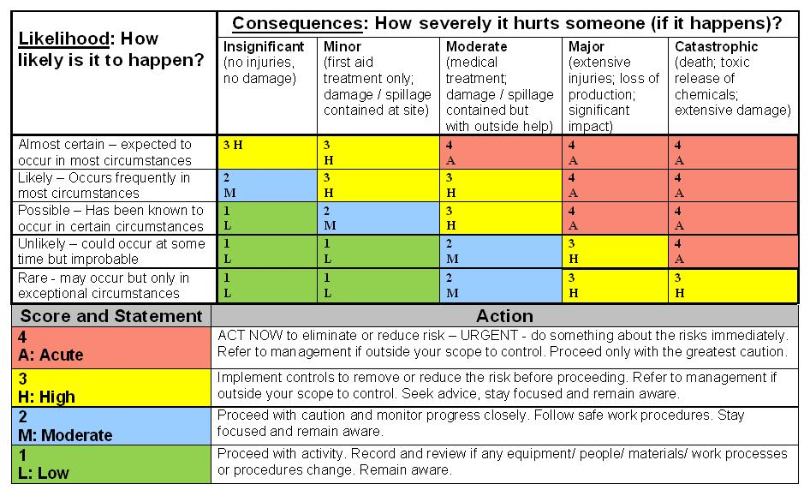

|  |  |
| --- | --- |
| **How do you assess the level of risk using this calculator?**   1. **Consider the possible Consequences should the risk eventuate** (How severely could it hurt someone how much damage could it cause if it happens?) 2. **Consider the likelihood of risk eventuating under the stated circumstances** (apply knowledge and experience of the risk and/or obtain advice from someone who knows) 3. **Marry the two to arrive at the Risk Level** | **What do you do about it?**   1. **If this is your Initial Risk Level, apply existing controls or develop controls to eliminate or reduce the Risk Level** (Refer [Hierarchy of Controls](http://www.bee.qut.edu.au/study/current/health/documents/CP097V7RMPolicyApr2010.doc#hierarchy)) 2. **Re-assess what the Risk Level will be after the controls are applied (Residual Risk Level)** 3. **Carry out the Action Required for the Residual Risk Level as per the table above** |

Return to Risk Register